Name | Geoffrey Beenie P. Orpia | Section | ________________________________
Date | 09/10/2026 | Time Started | 6:00PM
Time Submitted | 7:19PM | Score | ________________ / 100

Instructions

This exam checks what you can build on your own with everything covered in the Week 1 and Week 2 lab worksheets: JavaScript essentials, components and props, Flexbox layout, state and hooks, navigation, FlatList, forms and validation, AsyncStorage, fetch, and basic visual polish.

What You Are Building
A small app called ContactsLite: one screen lists saved contacts, another screen adds a new one. It is a NEW, separate project from your Week1Labs coursework — this exam tests what you can do independently, not what's already written in your old files.

Time Limit
90 minutes, strictly timed. Submit whatever you have when time is called — partial, working progress earns partial credit. An unfinished app with clean, correct code for the parts you completed will always score better than a rushed, broken attempt at everything.

What You May Use
- Your own computer, VS Code, Android Studio/Xcode emulator, and Expo.
- Your completed Week 1 and Week 2 lab worksheets and your own past code, for reference only — not for copy-pasting entire files.
- Only two windows are open (one for browser which has 2 tabs for GitHub/official documentation and google classroom only and one for VSCode) and split vertically.
- Official documentation: reactnative.dev, docs.expo.dev, react.dev.

What You May NOT Use
- Cheating of any kind.
- Phone is for Expo app usage only and should be put on top of the system unit.
- Asking a classmate, instructor hints beyond basic clarification, or messaging apps.
- Copying another student's project, in whole or in part.

WATCH OUT: Using any of the above during this exam will be treated as academic dishonesty under your institution's policy.

Grading Rubric
100 points total, split across 7 tasks. Read every task's acceptance criteria before starting — partial completion still earns partial points.
Task | Topic Covered | Points
Task 1 | Reusable Component & Props (ContactCard) | 10
Task 2 | Rendering Lists with FlatList | 15
Task 3 | Forms, State & Validation (Add Contact) | 20
Task 4 | Saving Data with AsyncStorage | 15
Task 5 | Talking to a Web API with fetch | 10
Task 6 | Visual Polish (Icons) | 10
Task 7 | JavaScript Essentials Quiz | 20

TIP: Suggested order: do Task 7 (the written quiz) first while your mind is fresh, then build Tasks 1 through 6 in order — each one builds on the last.

Starter Setup — Read This Before Starting the Clock

The project skeleton below is GIVEN to you — type it in exactly as shown before you start timing yourself. It handles the navigation wiring so your 90 minutes go toward the skills actually being tested, not boilerplate.

Create the Project
STEP 1 Set up ExamAppSetB
cd Desktop
npx create-expo-app@latest ExamApp --template blank
cd ExamApp
code .
Install the two packages you'll need for the exam:
npx expo install @react-navigation/native @react-navigation/native-stack
npx expo install react-native-screens react-native-safe-area-context
npx expo install @react-native-async-storage/async-storage

STEP 2 Create the file structure
Create a components folder with ContactCard.js inside, and a screens folder with BookListScreen.js and AddBookScreen.js inside.
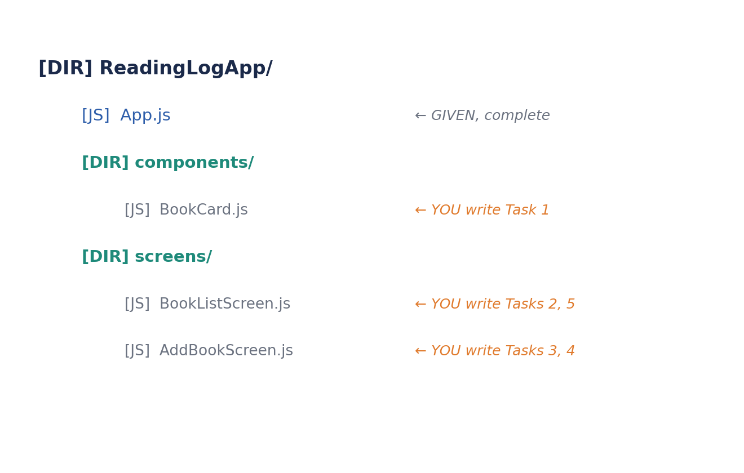
Given Code — Type This In First
Replace the entire contents of App.js with the code below exactly as written. This handles navigation and shares books + setBooks with both screens through props — you do not need to modify this file for the exam.
STEP A App.js (GIVEN)
import { useState } from 'react';
import { NavigationContainer } from '@react-navigation/native';
import { createNativeStackNavigator } from '@react-navigation/native-stack';
import BookListScreen from './screens/BookListScreen';
import AddBookScreen from './screens/AddBookScreen';

const Stack = createNativeStackNavigator();

export default function App() {
const [books, setBooks] = useState([
{ id: '1', title: 'Noli Me Tangere', author: 'Jose Rizal', read: true },
{ id: '2', title: 'The Hobbit', author: 'J.R.R. Tolkien', read: false },
]);

return (
<NavigationContainer>
<Stack.Navigator initialRouteName="BookList">
<Stack.Screen name="BookList" options={{ title: 'My Reading Log' }}>
{(props) => (
<BookListScreen {...props} books={books} setBooks={setBooks} />
)}
</Stack.Screen>
<Stack.Screen name="AddBook" options={{ title: 'Add Book' }}>
{(props) => (
<AddBookScreen {...props} books={books} setBooks={setBooks} />
)}
</Stack.Screen>
</Stack.Navigator>
</NavigationContainer>
);
}

NOTE: This pattern — {(props) => <Screen {...props} extraData={x} />} — lets a screen receive both its normal navigation prop AND extra props from App.js. You'll use books and setBooks inside BookListScreen.js and AddBookScreen.js exactly like you used props in your Week 1 labs.

STEP B components/BookCard.js (STUB — you complete Task 1)
import { View, Text, StyleSheet } from 'react-native';

// TODO Task 1: accept `title` and `author` as props and display them.
// Use Flexbox to lay the card out neatly (e.g. title bold on top, author below).

export default function BookCard(props) {
return (
<View style={styles.card}>
{/* your layout here */}
</View>
);
}

const styles = StyleSheet.create({
card: {
// TODO: style this card
},
});

STEP C screens/BookListScreen.js (STUB — you complete Tasks 2, 5, part of 6)
import { View, Text, FlatList, Button, StyleSheet } from 'react-native';
import BookCard from '../components/BookCard';

export default function BookListScreen({ navigation, books, setBooks }) {
// TODO Task 5: fetch a fun fact and store it in state; display it above the list.

// TODO Task 2: render `books` with FlatList + BookCard.
// - show a ListEmptyComponent message when there are no books
// - show a header like "2 books saved" (correct singular/plural)

return (
<View style={styles.container}>
<Button title="Add Book" onPress={() => navigation.navigate('AddBook')} />
{/* your FlatList goes here */}
</View>
);
}

const styles = StyleSheet.create({
container: { flex: 1, padding: 16 },
});

STEP D screens/AddBookScreen.js (STUB — you complete Tasks 3, 4)
import { useState } from 'react';
import { View, Text, TextInput, Button, StyleSheet } from 'react-native';

export default function AddBookScreen({ navigation, books, setBooks }) {
// TODO Task 3: build a form (title + author TextInputs).
// - validate both fields are non-empty; show an inline error if not
// - on success, add the new book and navigate back to BookList

return (
<View style={styles.container}>
{/* your form goes here */}
</View>
);
}

const styles = StyleSheet.create({
container: { flex: 1, padding: 16 },
});

CHECKPOINT: Once all four files above are saved and npx expo start runs without errors, start your 90-minute timer and move on to Task 7.

Task 7 — JavaScript Essentials Quiz (20 points, do this first)

Write your answer on the blank line(s) under each item. These are short — don't overthink them.
1. (4 pts) This code fails to run. Explain why in one sentence, then rewrite it correctly.
const MAX_BOOKS = 20;
MAX_BOOKS = 40;
Your answer:
A variable declared with const cannot be reassigned, so use let to allow its value to change.

2. (4 pts) Rewrite this function as an arrow function assigned to a constant named getBookLabel.
function getBookLabel(title, author) {
return title + ' by ' + author;
}
Your answer:
const getBookLabel = (title, author) => title + ' by ' + author;
console.log(getBookLabel)

3. (4 pts) Given const pages = 320;, write one console.log line using a template literal that prints exactly: This book has 320 pages
const pages = 320;
console.log(______________________________);
Your answer:

console.log(`This book has ${pages}\npages`);

4. (4 pts) Fill in the blank so unreadBooks contains only the books that are NOT yet read.
const books = [{ title: 'A', read: true }, { title: 'B', read: false }, { title: 'C', read: false }];
const unreadBooks = books.filter(______________________________);
Your answer:
const books = [{ title: 'A', read: true }, { title: 'B', read: false }, { title: 'C', read: false }];
const unreadBooks = books.filter(book => !book.read);
unreadBooks will be: [{ title: 'B', read: false }, { title: 'C', read: false }]

5. (4 pts) Fill in the blank to destructure title and author out of a single book object.
const book = { title: 'The Hobbit', author: 'J.R.R. Tolkien' };
const ______________________________ = book;
Your answer:
const book = { title: 'The Hobbit', author: 'J.R.R. Tolkien' };
const { title, author } = book;

console.log(title); // Outputs: The Hobbit
console.log(author); // Outputs: J.R.R. Tolkien

Task 1 — Reusable Component & Props (10 points)

File: components/BookCard.js
Complete BookCard so it accepts title and author as props and displays them in a neatly styled card using Flexbox.

Acceptance Criteria
☐ BookCard accepts title and author as props (destructured or via props.title / props.author).
☐ Both values are displayed using <Text> components.
☐ The card uses Flexbox properties (e.g. flexDirection, padding, or similar) so it doesn't look like plain unstyled text.
☐ The title is visually distinguished from the author (e.g. bold, larger, or a different color).
NOTE: This is the same pattern as TaskCard from your Week 1 labs — props in, styled View + Text out.
Task 2 — Rendering Lists with FlatList (15 points)

File: screens/BookListScreen.js
Render the books array (received as a prop) using FlatList and your BookCard component.

Acceptance Criteria
☐ A FlatList is used (not .map() to build the list by hand) with data={books}.
☐ keyExtractor is provided and uses each book's id.
☐ renderItem passes title and author into a BookCard for each book.
☐ ListEmptyComponent shows a friendly message when books is empty (e.g. "No books yet.").
☐ A header line above the list shows the correct count and grammar: "1 book saved" vs "3 books saved" (singular vs plural handled correctly, not just always "books").
TIP: The singular/plural check is a small conditional-rendering task in disguise — a ternary like books.length === 1 ? 'book' : 'books' is enough.

Task 3 — Forms, State & Validation (20 points)

File: screens/AddBookScreen.js
Build a form with two text fields (title and author) that validates input before adding a new book and returns to the list.

Acceptance Criteria
☐ Two TextInput fields exist: one for title, one for author, each backed by its own useState.
☐ Tapping Add/Save with either field empty does NOT add a book, and instead shows a visible error message on screen.
☐ Tapping Add/Save with both fields filled adds a new book object ({ id, title, author, read: false }) to the books array using setBooks.
☐ Each new book gets a unique id (e.g. Date.now().toString()).
☐ After successfully adding, the app navigates back to the BookList screen automatically.
☐ After successfully adding, both input fields are cleared.
WATCH OUT: Remember: never mutate the books array directly (no .push()). Always build a new array with the spread operator, e.g. setBooks([...books, newBook]).
Task 4 — Saving Data with AsyncStorage (15 points)

File: App.js (the books state lives here)
Make the book list survive fully closing and reopening the app.

Acceptance Criteria
☐ A useEffect saves books to AsyncStorage every time it changes (dependency array: [books]).
☐ A separate useEffect loads any saved books once when the app starts (empty dependency array: []).
☐ If saved data exists, it replaces the default 2 sample books on startup.
☐ Tested live: adding a book, fully closing the app, and reopening it shows the book still there.
NOTE: You already installed @react-native-async-storage/async-storage in the starter setup — just import it into App.js where you'll write this logic.

Task 5 — Talking to a Web API with fetch (10 points)

File: screens/BookListScreen.js
Fetch one piece of live data from the internet and display it above your book list.

Acceptance Criteria
☐ A useEffect calls fetch() once when the screen loads (empty dependency array).
☐ The fetched result is stored in state and displayed with a <Text> component.
☐ A .catch() provides a backup value so the app doesn't break if the request fails.
☐ Any free API that needs no login or API key is acceptable — for example https://api.quotable.io/random for a reading-motivation quote, or any similar public JSON endpoint.
TIP: This can be as simple as showing an inspirational quote about reading — the goal is a working fetch → .then() → setState chain, not a specific API.
Task 6 — Visual Polish with Icons (10 points)

Files: components/BookCard.js and screens/BookListScreen.js
Replace at least one plain text button or label with a real icon from @expo/vector-icons, and add a delete feature.

Acceptance Criteria
☐ @expo/vector-icons (e.g. Ionicons) is imported and used at least once — no separate install needed, it ships with Expo.
☐ BookCard accepts an onDelete prop and shows a delete icon (e.g. trash-outline) that calls it when pressed.
☐ BookCard shows a different icon depending on the read status (e.g. checkmark-circle when read, book-outline when not).
☐ Deleting a book removes it from the books array using .filter(), not by mutating the array directly.
☐ The deleted book disappears from the list immediately without a manual reload.
TIP: If you're short on time, a single working delete icon that actually removes the right book is worth more than several unfinished polish attempts.

Submitting Your Exam on GitHub

This exam goes into its OWN new repository — not your weekly coursework repo — so your instructor can grade it in isolation.

Steps
STEP 1 Create a new GitHub repository
Go to github.com, click New, and name it PracticalExamB-YourLastName (replace with your actual last name).
Keep it Public, do not add a README, then click Create repository.
STEP 2 Connect and push, whenever time is called
In VS Code's terminal, inside ReadingLogApp:
git init
git add .
git commit -m "Practical exam Set B submission"
git branch -M main
git remote add origin https://github.com/YOUR-USERNAME/PracticalExamB-YourLastName.git
git push -u origin main

STEP 3 Submit your link immediately
Copy your repository's HTTPS link and submit it exactly as instructed by your proctor — do not keep editing your code after this point.
WATCH OUT: If time runs out mid-task, commit and push anyway. A partially finished, honestly submitted app is graded on what it does correctly — an empty submission cannot be.

